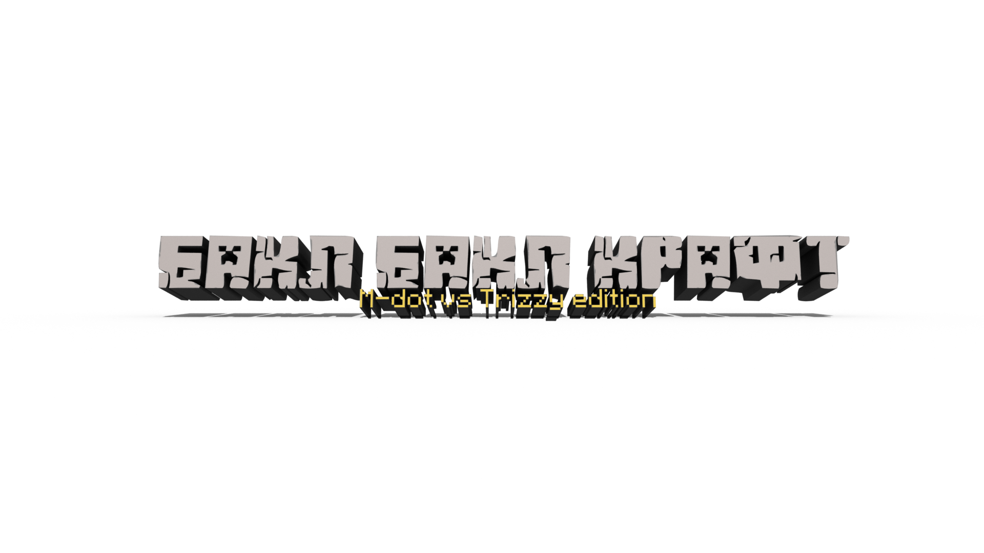 

**FINAL REPORT**

**BAQLBAQLCRAFT By**

**Zhasylanuly Muslim & Kairatov Batyrkhan**

A report submitted in partial fulfillment of the requirements for the Programming Discipline

at Nazarbayev Intellectual School

**Supervised by Ms. Agis Iskaziyeva**

**Grade____________**

**Date____________**

**Sign____________**

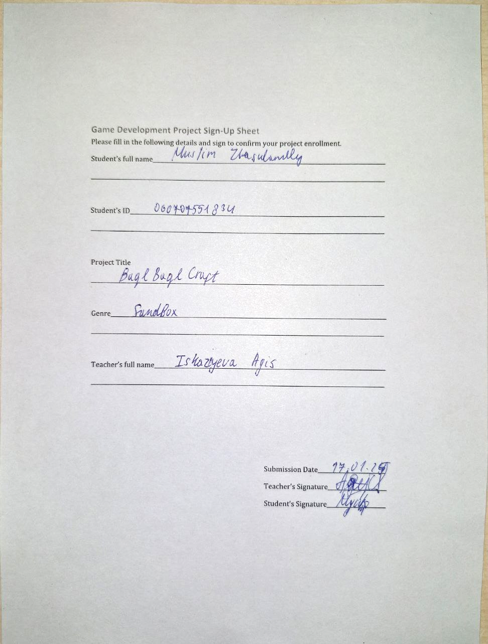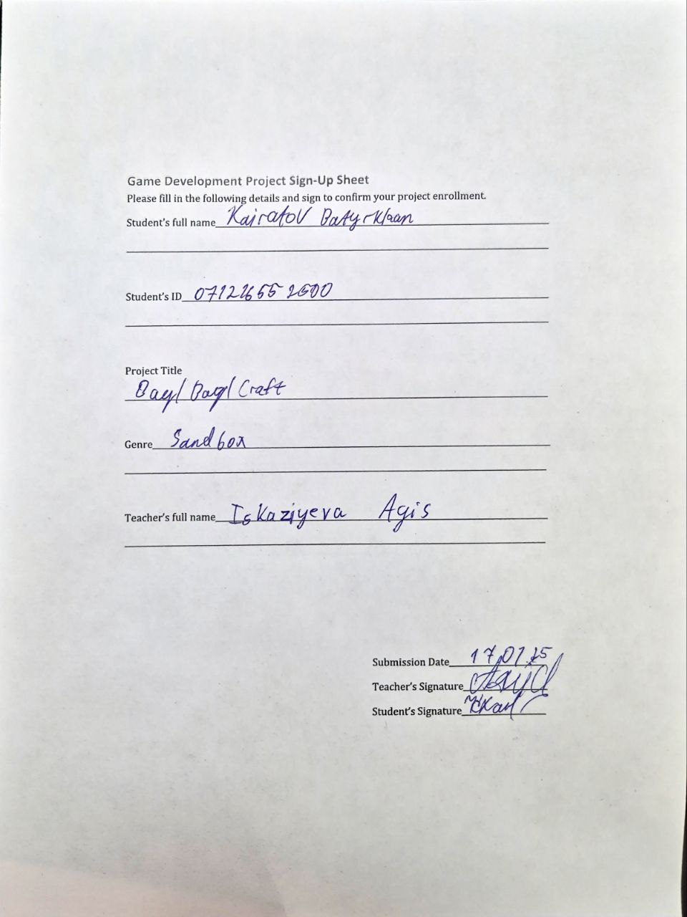

# Table of Contents

Table of Contents 1

Table of Figures 2

1. GAME CONCEPT DOCUMENT (GCD) 3

1.1 Game Title 3

1.2 Genre 3

1.3 Concept Overview 3

1.4 Target Audience 3

1.5 Initial Sketches (characters, levels) 3

2. GAME DESIGN DOCUMENT (GDD) 4

2.1 Game Overview 4

2.2 Gameplay Mechanics 4

2.3 Level Design 4

2.4 Characters and Objects (descriptions, roles) 4

2.5 Wireframes of Screens 4

2.6 Controls Plan 4

3. DEVELOPMENT DOCUMENTATION 5

3.1 Development Environment Setup 5

3.2 Key Libraries Used (e.g., PyGame, PIL, Wave) 5

3.3 Implementation Details: 5

3.4 Code Snippets 5

4. TESTING AND DEBUGGING LOGS 6

4.1 Testing Scenarios 6

4.2 Bugs Found and Solutions 6

4.3 Feedback and Adjustments 6

5. PRESENTATION MATERIALS 7

5.1 Startup Pitch Outline 7

5.2 Game Demo and Features 7

5.3 Future Development Plans 7

Table of Figures

Figure 1: Miras. 4

Figure 2: first world generation. 4

Figure 4: dirt block. 6

Figure 5: grass block. 6

Figure 5.1: grass block. 6

Figure 6: stone block. 6

Figure 7: wood block. 6

Figure 8: bricks block. 7

Figure 9:bedrock. 7

Figure 10: first world generation. 7

Figure 11: Advanced world generation. 8

# 1. GAME CONCEPT DOCUMENT (GCD)

## Game Title

BaqlBaqlCraft

## Genre

Sandbox

## Concept Overview

BaqlBaqlCraft is a creative sandbox game inspired by the mechanics and world-building aspects of Minecraft but developed using Python. Players can explore, mine, craft, and build within an expansive procedural world, offering both survival and creative modes.

## Target Audience

BaqlBaqlCraft is designed for players of all ages who enjoy open-world exploration, creativity, and problem-solving. It is particularly aimed at fans of sandbox games, Python enthusiasts, and players who enjoy games with a mix of construction, resource management, and adventure.

## Initial Sketches (characters, levels)

Miras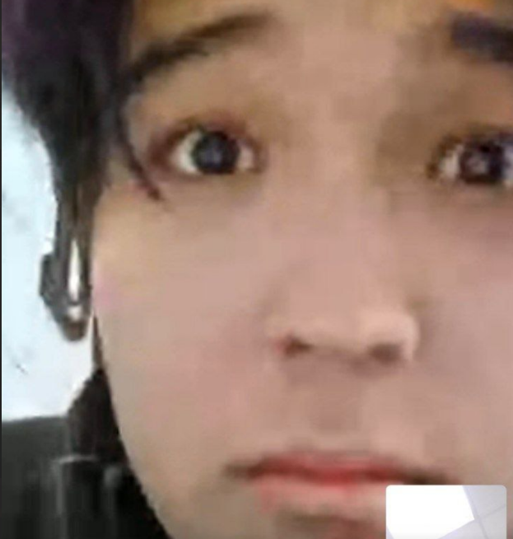

Figure 1: Miras.

The sandbox genre of the game refers to a style of gameplay where there is a single, open world that is entirely unique each time it is created. This uniqueness is achieved through a process of random generation, ensuring that no two game worlds are ever the same.

Figure 2: first world generation.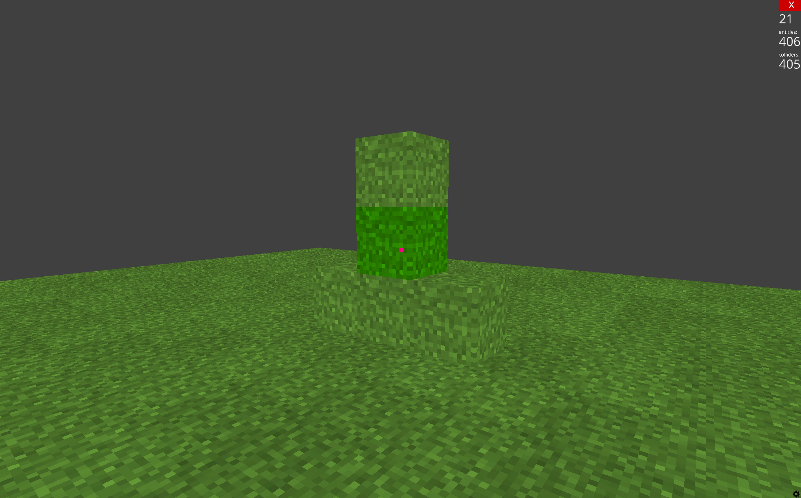

# 2. GAME DESIGN DOCUMENT (GDD)

## Game Overview

This game does not have a particularly deep or complex storyline, but it offers an engaging and entertaining sandbox experience. The open-ended gameplay allows players to unleash their creativity by constructing various structures, experimenting with different designs, or even crafting their own personal narrative within the game world. However, the presence of enemies will add an extra layer of challenge, as they will continuously harass the player, making the adventure much more difficult and intense.

## Gameplay Mechanics

Breaking blocks, placing blocks, attacking enemies, walking.

## Level Design

A procedurally generated map that will be completely random and unique every time the game starts anew, ensuring a fresh experience with each playthrough.

## Characters and Objects (descriptions, roles)

Characters:

Miras. Hostile mob that tries to get close to the player in any way possible.



Figure 3: Miras.

Objects:

Dirt block



Figure 4: dirt block.

Grass block



Figure 5: grass block.



Figure 5.1: grass block.

Stone



Figure 6: stone block.

Wood

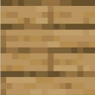

Figure 7: wood block.

Bricks

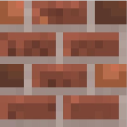

Figure 8: bricks block.

Bedrock

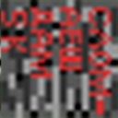

Figure 9:bedrock.

## Wireframes of Screens

Figure 10: first world generation.

Figure 11: Advanced world generation.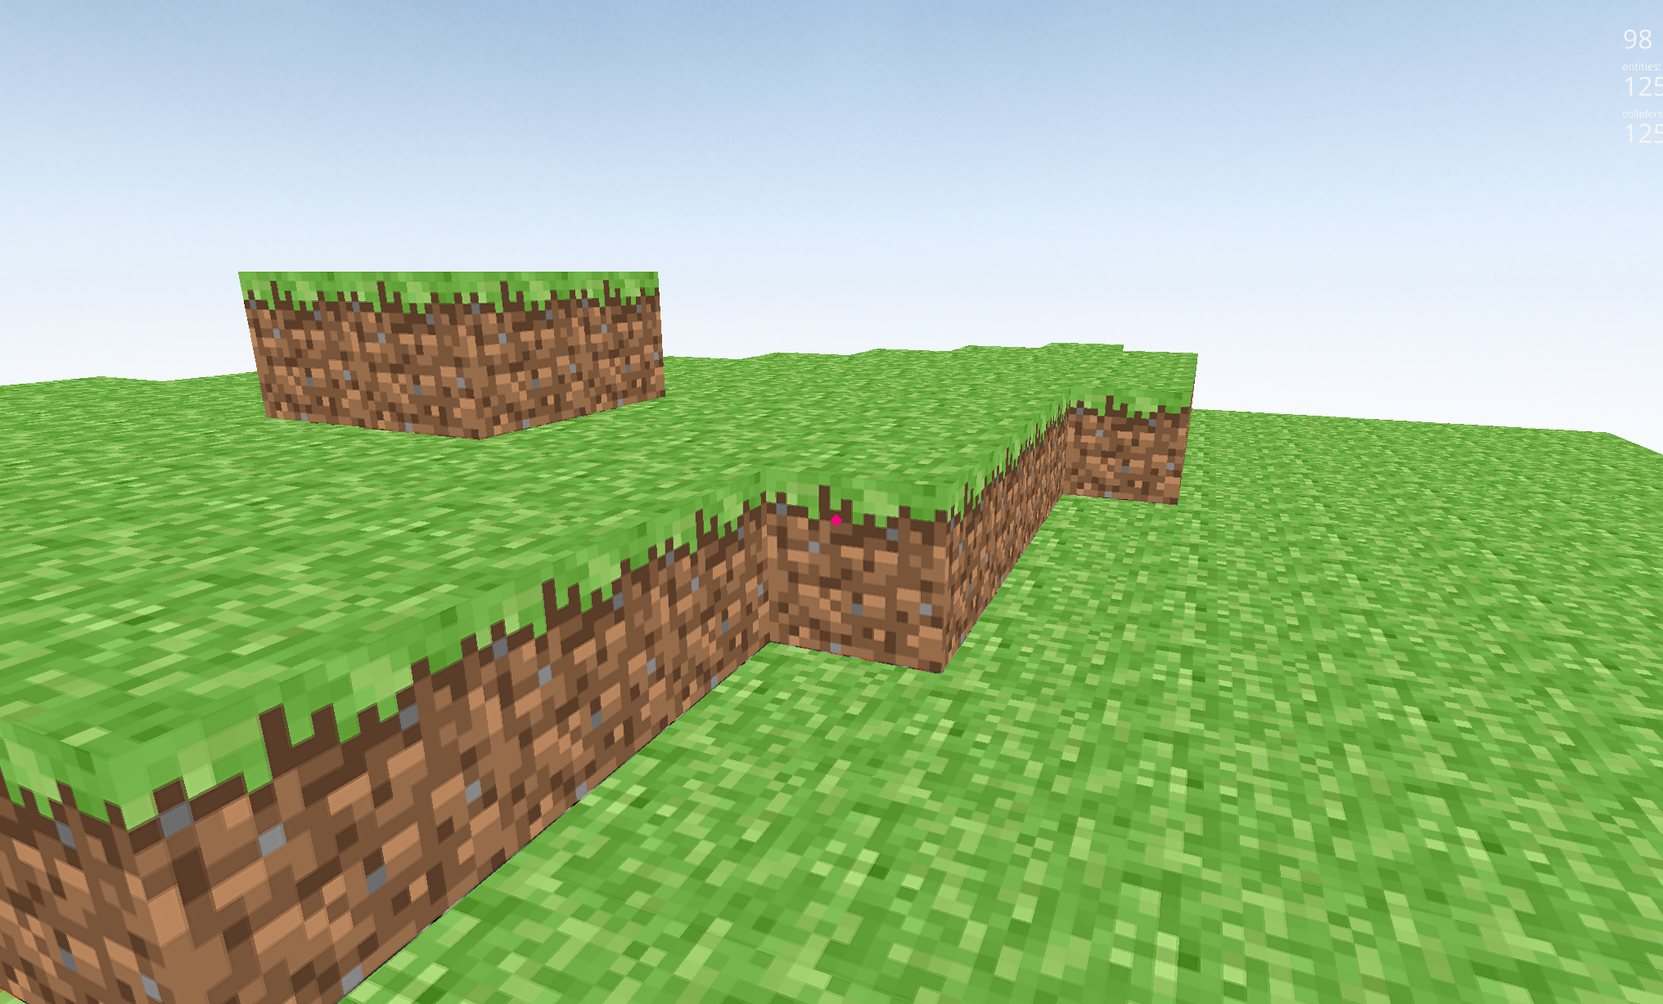

## 2.6 Controls Plan

WASD - Player movement

Space - Jump

Mouse - Camera movement

Right Mouse - Breaking block if block selected / Attack if sword selected

Left Mouse - Placing selected mouse

1 - Grass Block

2 - Dirt Block

3 - Stone Block

4 - Brick block

5 - Wood block

6 - Sword

Q - Exit game

ESC - Exit game

# 3. DEVELOPMENT DOCUMENTATION

## Development Environment Setup

Download Thonny app and Ursina game engine for python.

## Key Libraries Used (e.g., PyGame, PIL, Wave)

Ursina, perlin_noise, random.

## Implementation Details:

Game Window and Loop

Core Mechanics (movement, collision, animation)

Advanced Features (sound, text, effects)

## Code Snippets

**Generation of the blocks at the start of the game development:**

*app = Ursina()*

*for x in range(16):*

*for z in range(16):*

*Entity(model="cube", texture="white_cube", position=Vec3(x,0,z))*

*app.run()*

**Unloading blocks that are too far from the player:**

*def unload_far_chunks():*

*if not player:*

*return*

*player_chunk_x = int(player.x // chunk_size)*

*player_chunk_z = int(player.z // chunk_size)*

*to_remove = [(cx, cz) for cx, cz in chunk_dict.keys()*

*if abs(cx - player_chunk_x) > render_distance or abs(cz - player_chunk_z) > render_distance]*

*for chunk in to_remove:*

*for block in chunk_dict[chunk]:*

*destroy(block)*

*del chunk_dict[chunk]*

# 4. TESTING AND DEBUGGING LOGS

## Testing Scenarios

Run the game and test WASD and Spacebar buttons to ensure correct movement.

Run the game and test Q and ESC buttons to properly exit the game.

Press 1-5 and left, right click of mouse to test correct placement of blocks and their breaking.

Testing coherence of generation of the world, by walking around, trying to fall from the map.

In the game, find an entity “Miras” to test its behavior.

## Bugs Found and Solutions

Bug: Music stops after playing once. Solution: Add feature loop.

Bug: player can fall from the world. Solution: add new unbreakable block, bedrock.

Bug: bad generation of world using python loops. Solution: using perlin_noise library to generate world.

## Feedback and Adjustment

Feedbacks: Player goes through block from underneath; Loud music; No life in the game;

Adjustments: Introduction of new feature where player can phase through blocks from underneath. Volume of music was reduced by audio editor, and Miras entity was added to make game world more alive.

# 5. PRESENTATION MATERIALS

## Startup Pitch Outline

**Introduction**: BaqlBaqlCraft is a sandbox game developed in Python, inspired by Minecraft, but featuring unique procedural generation and mechanics.

**Game Overview:** A procedurally generated sandbox game where players can mine, build, and survive in a dynamically created world. The game includes exploration, and combat mechanics.

**Development Plan:** The game is in development with planned features like new biomes, characters, survival mechanics, and improved AI. The roadmap includes optimizations and future updates.

**Team:** Developed by Zhasylanuly Muslim & Kairatov Batyrkhan under the supervision of Ms. Agis Iskaziyeva.

## Game Demo and Features

Figure 12: Advanced world generation.

Figure 13: Miras in game.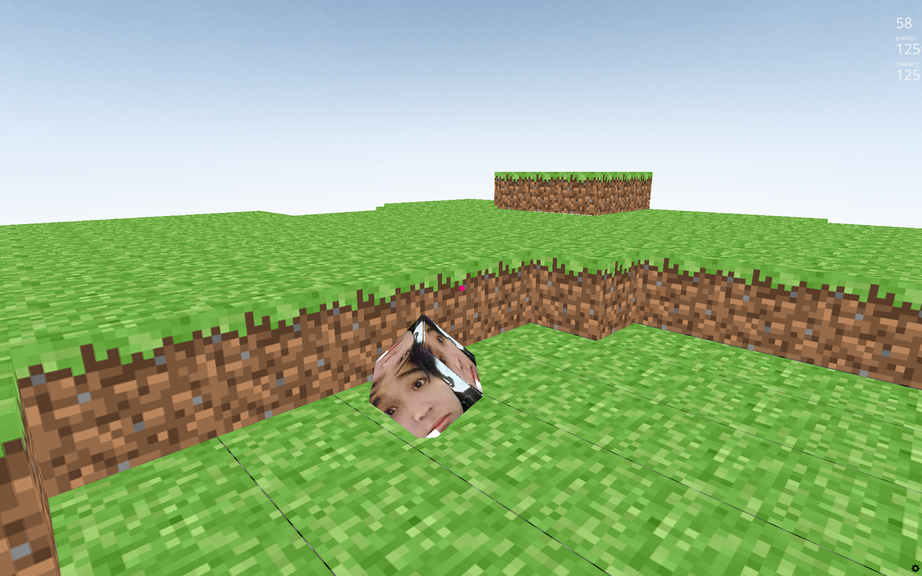

Figure 14: blocks in game.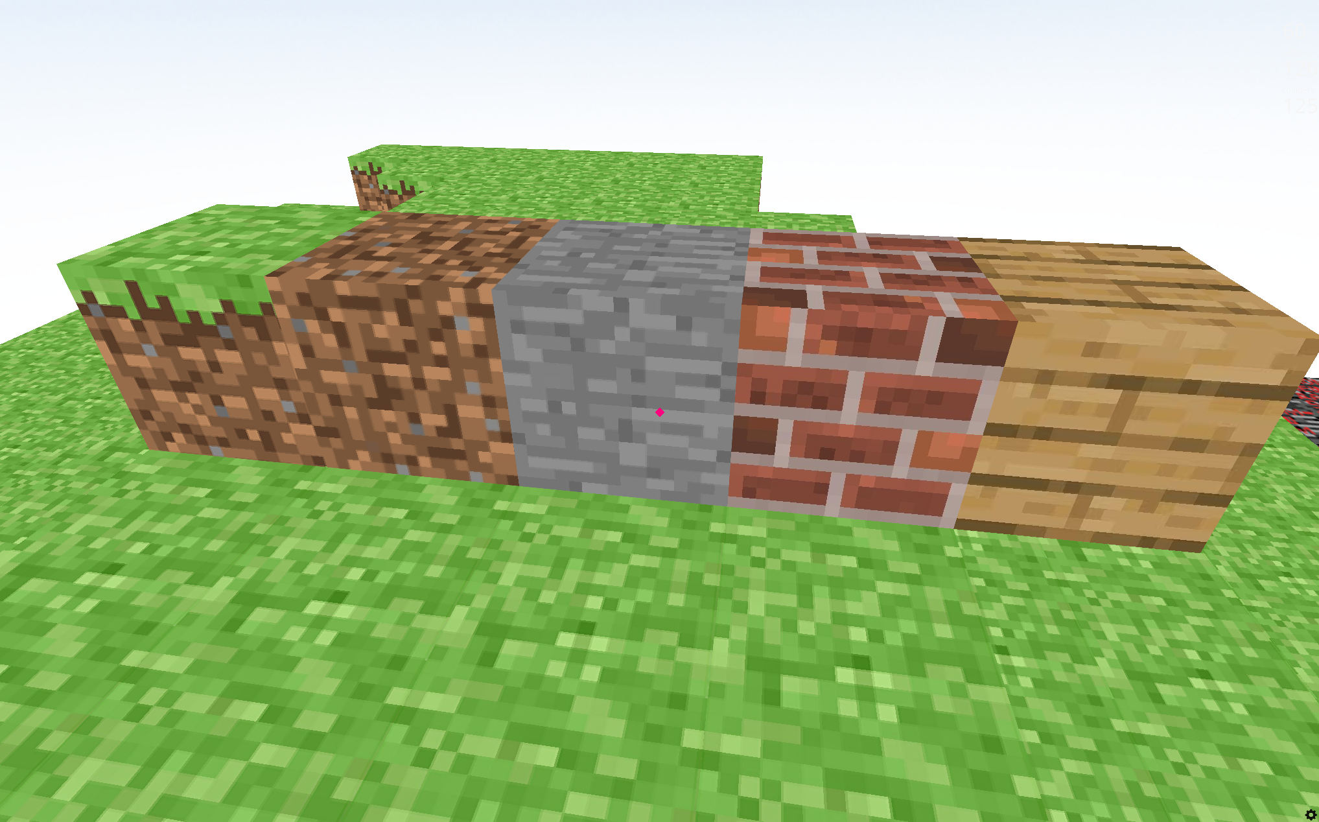

## Future Development Plans

Optimization of the game, and adding trees, caves, cliffs, mountains, river and oceans to the generation.

Adding survival game mode where player can take damage, heal, die, respawn, eat food.

Adding player’s hand and showing selected item(1-6 buttons).

Adding new characters:

Zombies. Hostile creatures who will appear at nighttime and try to kill the player.

P.Diddy. The main boss of the game. Will drop baby oil after defeat.

Timur. The homeless man. Will trade things for food.

Michael Jackson. The only user of secret technique “Hee-Hee”. Will teach new secret techniques after leveling.

Improving Miras entity: Making it the hardest enemy of the game. He has many HP and defense because of his fat. Will drop KFC or McDonalds’ food.